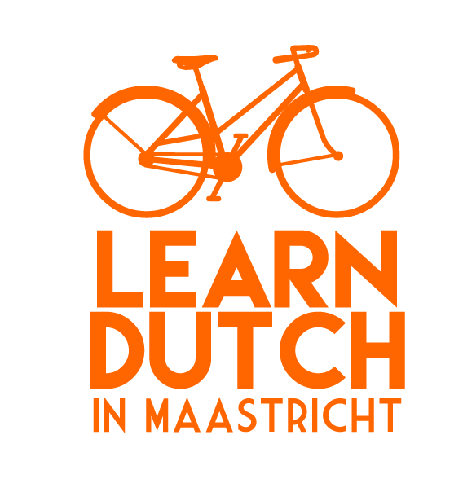
General Terms & Conditions

For Private Individuals
General
- Learn Dutch in Maastricht general terms and conditions apply to all agreements between Learn Dutch in Maastricht, having its registered seat at Statensingel 2, 6217KD Maastricht (“Learn Dutch in Maastricht”), and any person (“Student”) purchasing course(s), training(s), classes, or similar services (“Courses”).
- The Courses can be distinguished in (i) courses with a fixed schedule and fixed starting date (“Group Courses”) and (ii) classes with a schedule to be arranged between Learn Dutch in Maastricht and the Student (“Private Lessons”).
- The Agreement starts of the date that the Student wishing to participate in a Course when the Student (i) subscribes for a Course (“Enrolment”) and (ii) The Student has paid the Course Fees. The Confirmation of Enrolment, together with these Terms, are hereinafter to be referred to as “Agreement”.
Enrolment
Enrolment for a Course can be done online through the website by ordering a Course, or by e-mail. The Student will receive a written confirmation (by e-mail) of the Enrolment (“Confirmation of Enrolment”). With Private Lessons the invoice sent to the Student can be seen as the Confirmation of Enrolment.
Courses
Proficiency level group courses
- The Group Courses provided by Learn Dutch in Maastricht are divided in different proficiency levels. Students may require an entry level before being admitted to a Course. Admittance to the Course (other than starting level) can be conditional upon the Student passing the intake test, to be assessed by Learn Dutch in Maastricht.
- During the Course the Student has enrolled to, the Student may request to be transferred to a different proficiency level. Learn Dutch in Maastricht shall honour such request in case all of the following apply: (i) The second lesson of the current Course has not taken place yet; and (ii) the Student has not requested for a transfer previously; and (iii) there’s capacity to fit the Student in the class for the proficiency level the Student has requested; and (iv) the Student has reached the entry level of the requested proficiency level.

Certificate
The Student will receive a Certificate of Participation (“Certificate”) when they have successfully completed a Group Course. A Group Course is successfully completed when the Student attended at least 75% of the lessons in the group course.
Location
Courses take place at the location which is stated in the confirmation of the Agreement. The standard location of the classes is at BrightSpace, Statensingel 2, 6217KD in Maastricht.
Public Holidays
Classes may take place on public holidays. All Course dates are communicated online prior to the Student and therefore the Students assumes responsibility for the selection of the Course including its Course dates.
Transfer
Students cannot be transferred to a later session during the term of the Group Course the Student has enrolled to for reasons within the Student’s control. These reasons can include but are not limited to: work schedule, travel, vacation, personal reasons.
Conduct
Learn Dutch in Maastricht reserves the right to dismiss any Student displaying unacceptable, discriminating, racist, sexual, aggressive or other inappropriate behaviour to the reasonable opinion of Learn Dutch in Maastricht, at any time, without the Student being entitled to any form of refund, compensation or damages.
Prices and payment conditions
- The prices of the Courses and Private Lessons are listed on Learn Dutch in Maastricht’s website. All prices stated on the website are in EURO and are inclusive of VAT. Learn Dutch in Maastricht cannot be held responsible for typographical mistakes.
- All the Courses to be attended by the Student must be paid prior to the starting date. Payment can be done by wire transfer to Learn Dutch in Maastricht’s bank account (Bank: NL84 KNAB 0257 2193 07 t.n.v. Learn Dutch in Maastricht, Bic: KNABNL2H) stating the Student’s name and Course name, IDeal or by a Paypal/Credit card transfer.
- Learn Dutch in Maastricht shall provide invoicing on request.

Cancellation
Cancellation by the Student
- The Student’s inability to attend a class (or entire Course) of a group course is at risk of the Student and Learn Dutch in Maastricht has no obligation to refund any (part of) Course Fees.
- The Student may cancel the registration for the Course up to 10 days before the start of the course and receive a full refund.
- In the event of circumstances beyond the Student’s reasonable control (such as illness which permanently inhibits a student from participating in the Course, an accident or death) the Course Fee will be reimbursed, upon receipt of a written request for cancellation and the Student has provided valid evidence of such occurrence, on a pro rata basis.
- The Private Lessons will be scheduled by common consent between the assigned teacher and the Student. Private lessons can be rescheduled if the Student gives at least 24 hours’ notice. The rescheduled lesson should take place within 14 days. There is a maximum of 2 lessons per 90 days that can be rescheduled for free.
Cancellation or rescheduling by Learn Dutch in Maastricht
Learn Dutch in Maastricht reserves the right to cancel any scheduled Group Course up to 24 hours prior to the scheduled start of such Course in case the number of enrolled Students for such course falls below the threshold for such Course. In such case Learn Dutch in Maastricht can postpone, cancel the course or limit the duration of the course. When this happens, the Student is free to reconsider their registration and the course fee will be refunded within 5 days if they do. Learn Dutch in Maastricht maintains the following threshold: Group Courses start with the minimum of six students.
Refunds
Refunds are wire transferred from Learn Dutch in Maastricht bank account within 5 workdays of receipt of communication and/or proof concerning stated above.
Communication
- All notices, under the agreement, to Learn Dutch in Maastricht can be made via e-mail to info@learndutchmaastricht.nl.
- Learn Dutch in Maastricht shall respond to all communication received either by post, e-mail or phone which requires response within 5 workdays from receipt of such communication.
- Learn Dutch in Maastricht shall only use the personal information of Students for the following purposes: (i) for registration and enrolment of the Student in the course; (ii) newsletters and commercial offers from Learn Dutch in Maastricht (not from any other third party); and (iii) any other communication from Learn Dutch in Maastricht relevant for the Student.
- If Students don’t want to receive any newsletters, commercial offers or any other communication from Learn Dutch in Maastricht, they can send Learn Dutch in Maastricht a written request. Personal information then will only be used for registration and enrolment.
Limitation of liability
- Learn Dutch in Maastricht shall not be liable under any agreement for any indirect, special, incidental, punitive or consequential damages, or any other similar damages under any theory of liability (whether in contract, tort, strict liability or any other theory). Further, Learn Dutch in Maastricht shall not be liable, in any way, for theft, damage or loss of the Student’s personal effects.
- The Student assumes all responsibility for the selection of the Course necessary to achieve the Student’s intended results, and for the use and results of the Course. Learn Dutch in Maastricht makes no warranty for any Course to be for for any intended purpose.
Image use
- Learn Dutch in Maastricht may take photos and videos of the Students for inclusion in promotional material (brochures, websites, etc.) unless the Student has explicitly communicated an objection to this upon enrolment.
- Learn Dutch in Maastricht, or its licensors, own all intellectual property in any work published either on its website, hardcopy hand-outs and digital works shown or provided to the Students. The Students shall not be allowed, without the prior written consent of Learn Dutch in Maastricht to copy, distribute, or use the materials in any other way as strictly necessary for successful completion of the Course.
Miscellaneous
- These Terms together with the Course registration form represents the entire agreement between the parties and supersedes any prior or current understandings, whether written or oral. If there is a conflict between these Terms and the Confirmation of Enrolment, the Confirmation of Enrolment will prevail.
- The Agreement will be governed by the laws of The Netherlands. The parties consent to the jurisdiction by the courts of Maastricht for any claim relating to this Agreement. Notwithstanding the parties’ right to submit a claim to the courts of Maastricht, the Student shall omit to try to resolve any dispute under the Agreement by submitting a formal complaint in accordance with Learn Dutch in Maastricht’s formal complaint procedure which shall be provided to the Student upon the Student’s earliest request.

